Steady State Limiting Safety System Settings Code Verification of a Fluoride Salt Cooled High Temperature Test Reactor

Yao Xiao^{1,2}, Rebecca Romatoski², Lin-wen Hu²

1, Xi’an Jiaotong University, Xi'an, Shaanxi, 710049, China
2, Massachusetts Institute of Technology, Cambridge, MA 02139, United States

I. INTRODUCTION
The Fluoride salt cooled High temperature Reactor (FHR) is an innovative reactor design that uses TRISO high temperature fuel with a low-pressure liquid salt. During 2001-2003, Oak Ridge National Laboratory (ORNL), Sandia National Laboratories (SNL) and the University of California, Berkeley (UCB) developed the Advanced High Temperature Reactor (AHTR) . It is a new design concept of a high temperature reactor with fluoride salt as the primary coolant as an alternative to gas-cooled reactors for high temperature applications. In the next few years, several studies of Fluoride-salt cooled High temperature Reactors (FHRs) delineate the potential for attractive economic performance while meeting high standards for reactor safety and security.

In China, the Chinese Academy of Sciences (CAS) started a strategic pilot science and technology special project “future advanced nuclear fission energy” in 2011. Within the scope of this project, the Shanghai Institute of Applied Physics (SINAP) will develop a Thorium-based Molten Salt Reactor (TMSR) nuclear energy system. A solid fuel test reactor will be constructed as the initial step to demonstrate the technical feasibility of a large-scale reactor . This reactor, designated as Solid Fuel Thorium-based Molten Salt Reactor (SF-TMSR), will be a fluoride salt cooled, static pebble bed reactor. The initial licensing power will be 2 MW, with a planned power upgrade to 20 MW . It will be the first liquid salt cooled, pebble bed test reactor in the world.

This paper presents verification of fortran code to calculate the Limiting Safety System Settings (LSSS) for steady state operation for the SF-TMSR, who's current design is briefly described in the second section. The preliminary safety analysis code, including models and assumptions, the engineering hot channel factors, and the temperature limits for LSSS are described in ICONE PAPER.
II. OVERVIEW OF THE CURRENT SF-TMSR DESIGN
The design of SF-TMSR is ongoing at SINAP, China, which is based on a test reactor design proposed by UCB . In the current design, the primary coolant in loop is a binary molten salt system of the 66.7% ⁷LiF-33.3% BeF₂ (mol), or flibe, originally used in the molten salt reactor (MSR) . Table I lists the thermophysical properties of flibe. The primary loop consists of pipes with inner diameter of 12.5 cm, reactor core, and double molten salt heat exchanger (IHX). Hastelloy N will be used to manufacture most of the structural components of SF-TMSR. The cross sectional view of the reactor core is shown in Fig. 1 . The core region of SF-TMSR is an octagonal prism that comprises of two parts: central control system channels zone and fuel pebbles zone. The core region is 138.6 cm high, and the opposite side distances are 139.0 cm and 134.69 cm. The width of the square central control system channels zone is 35.0 cm. The coolant flows upward through the core and removes the heat.

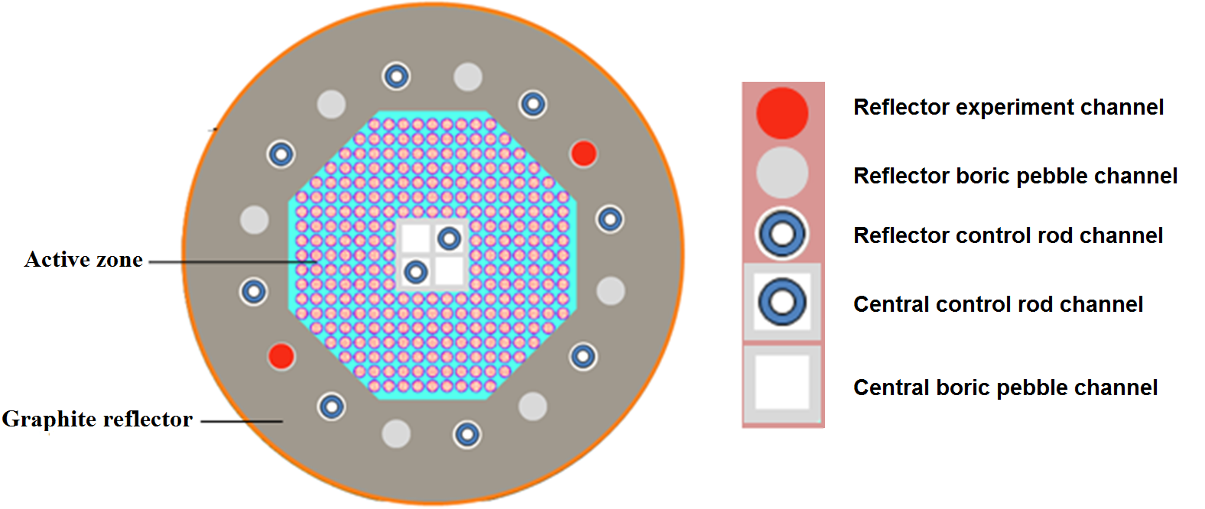
Fig. 1. SF-TMSR cross sectional view

The fuel pebbles in the active core zone are static and in an ordered arrangement with a packing fraction of 68.06%. The SF-TMSR uses the spherical fuel elements with TRISO particles containing UO₂. The pebble diameter is 6 cm and the fuel zone diameter is 5 cm with a 0.5 cm thickness graphite shell. The TRISO fuel particle consists of a UO₂ fuel kernel surrounded by a porous buffer layer, and successive isotropic layers of dense inner pyro carbon (IPyC), chemically vapor deposited silicon carbide (SiC), and a dense outer pyro carbon (OPyC) layer as listed in Table II. The fuel pebbles in the active core zone are static and in an ordered arrangement of 40 layers of pebbles with an average of 278 pebbles in each layer. The infinite packing fraction is 68.06%.

TABLE I
Properties of the Flibe Coolant
Salt (mol %) | ⁷LiF–BeF₂ (66.7–33.3)
Melting Point (°C) | 460
Boiling Point (°C) | 1400
Density (kg/m³), T (°C) | 2280–4884×10⁻⁴T
700 °C Heat Capacity (C_{p}) (J/kg∙K) | 2380
Viscosity (Pa∙s), T (°C) | 1.16×10⁻⁴×exp(3755/(T+273.15))
Thermal Conductivity (W/m∙K) | 1.0

TABLE II
Geometry and Composition of SF-TMSR Fuel Pebble
Region | Parameters | Component Dimension | Value (mm) | Material
Fuel  Pebble | Fueled region | Outer Radius | 25 | TRISO& Graphite
Fuel  Pebble | Pebble Shell | Thickness | 5 | Graphite
Fuel  Pebble | Pebble | Outside Radius | 30
TRISO Particle | Fuel Kernel | Outer Radius | 0.25 | UO₂
TRISO Particle | Porous Pyrolytic Carbon (PyC) | Thickness | 0.095 | Porous PyC
TRISO Particle | Dense Inner PyroCarbon (IPyC) | Thickness | 0.04 | PyC
TRISO Particle | Silicon Carbide (SiC), | Thickness | 0.035 | SiC
TRISO Particle | Dense Outer PyroCarbon (OPyC). | Thickness | 0.04 | PyC
TRISO Particle | TRISO Particle | Outside Radius | 0.46

The SF-TMSR is planned for three operation modes, which are zero power mode (<0.01 kW), high power mode I (2 MW, forced circulation) and high power mode II (20 MW, forced circulation) . The main parameters of the three operation modes are shown in Table III. The reactor will be licensed for 2 MW initially, and a subsequent power upgrade to 20 MW.

TABLE III
Main Design Parameters in the Three Operation Modes
Operation mode | Zero power mode | High power mode I | High power mode II
Thermal power (kW) | <0.01 | 2000 | 20000
Inlet temperature (°C) | 600 | 600 | 600
Outlet temperature (°C) | 600 | 620 | 700
Mass flow rate (kg/s) | N/A | 42.3 | 84.6
III. THE PRELIMINARY SAFETY ANALYSIS CODE
In the present work, a one-dimensional, steady-state, thermal hydraulic analysis code was developed to model the reactor core. The models were based on the three fundamental conservation principles: the mass, momentum and energy conservation equations. Detailed description of these coupled equations can be found in reference . With the assumption of one-dimensional flow, a single-channel model was adopted to simulate the hot channel and the core, and coolant and fuel temperatures were calculated as a function of axial position using the finite volume method to solve the conservation equations. The LSSS were determined with iterations being made for the reactor power and the steady-state average primary inlet and outlet temperature to find the conditions corresponding to the four LSSS temperature limits.
III.A. Hot Channel Model
The hot channel in this study is a hypothetical coolant channel as in a conventional research reactor, such as the MITR . It was assumed conservatively that the hot channel (one with the maximum radial peaking factor, F_{r}) receives the minimum amount of flow among all the coolant channels. This assumption establishes the lower bound of the thermal-hydraulic limits. The engineering hot channel factors account for possible deviations from nominal design specifications that may affect the thermal hydraulic calculation results. Specifically, they are defined for channel enthalpy rise (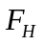), film temperature difference (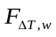) and fuel temperature rise (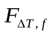) engineering hot channel factors in this work. A "vertical" approach was used to calculate the maximum fuel central temperature and the maximum coolant temperature using the engineering hot channel factors :

To calculate the maximum coolant temperature, use:
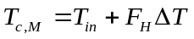 (10)

To calculate the maximum fuel surface temperature, use:
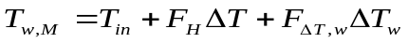 (11)

To calculate the maximum fuel central temperature, use:
(12)

where 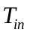 is the coolant channel inlet temperature,
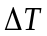 is the coolant temperature rise,
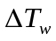 is the film temperature rise,
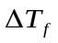 is the temperature difference between the surface and the center of a fuel pebble,
is the enthalpy rise engineering hot channel factor,
is the film temperature rise engineering hot channel factor,
is the fuel temperature rise engineering hot channel factor.
III.B. Engineering Hot Channel Factors
The engineering hot channel factors used are described in ICONE PAPER.
Because improvement in the determination of the SF-TMSR engineering hot channel factors requires further study, the existing set of factors is used for the present. An enthalpy rise engineering hot channel factor () of 1.172, a film temperature engineering hot channel factor () of 1.268 and a fuel temperature engineering hot channel factor () of 1.114 were adopted, respectively.
III.C. Derivation of the Temperature Limits for LSSS
The thermal hydraulic limits were chosen to provide a sufficient safe margin beyond the desired operating range as described in ICONE PAPER. The temperature limits chosen as the criterion for the LSSS derivation can be shown as follow:
T_{in} >470 ºC
T_{out} <720 ºC
T_{c,m} <1200 ºC
T_{f,m} <1300 ºC
Where T_{in} is the core inlet temperature,
T_{out} is the average core outlet temperature,
T_{c},_{m} is the maximum temperature of coolant,
T_{f,m} is the maximum temperature of fuel.

IV. DERIVATION OF THE LIMITING SAFETY SYSTEM SETTINGS
In the LSSS analysis, all the four temperature limits were considered to obtain the allowable operating region of the FHTR. This guarantees that temperatures will not challenge the material and fuel integrity in the reactor as long as the four limits are not exceeded. Specifically, the LSSS is derived for:
- The maximum reactor power.
- The maximum steady-state average primary outlet temperature.
- The minimum steady-state average primary inlet temperature.
- The minimum coolant mass flow rate. (Forced circulation operation only)
Thus, the SF-TMSR can operate with all four parameters simultaneously approaching their limits without fuel or material failure.

The LSSS for the SF-TMSR are calculated based on the following assumptions:
- The radial power peaking factor (F_{r}) is assumed for 1.4, which defines the ratio of the maximum power deposited in the hottest vertical fuel zone to the average power per vertical fuel zone.
- The axial power distribution is given in Fig. 2. Fig. 2 and the radial power peaking factor (F_{r}) 1.4 are obtained from SINAP .
- The coolant flow factor (F_{f}) equals 0.92, which is defined as the ratio of the primary coolant flow which cools the fueled region to the total flow. This value is adopted from the MITR.
- The channel flow disparity factor (d_{f}) equals 0.86, which is defined as the ratio of the minimum flow to the average flow in the coolant channels. This value is adopted from the MITR.
- The engineering hot channel factors summarized in Table V are appropriate.
- The primary loop is assumed 240.6 cm in height conservatively, which is the height of the reactor vessel .

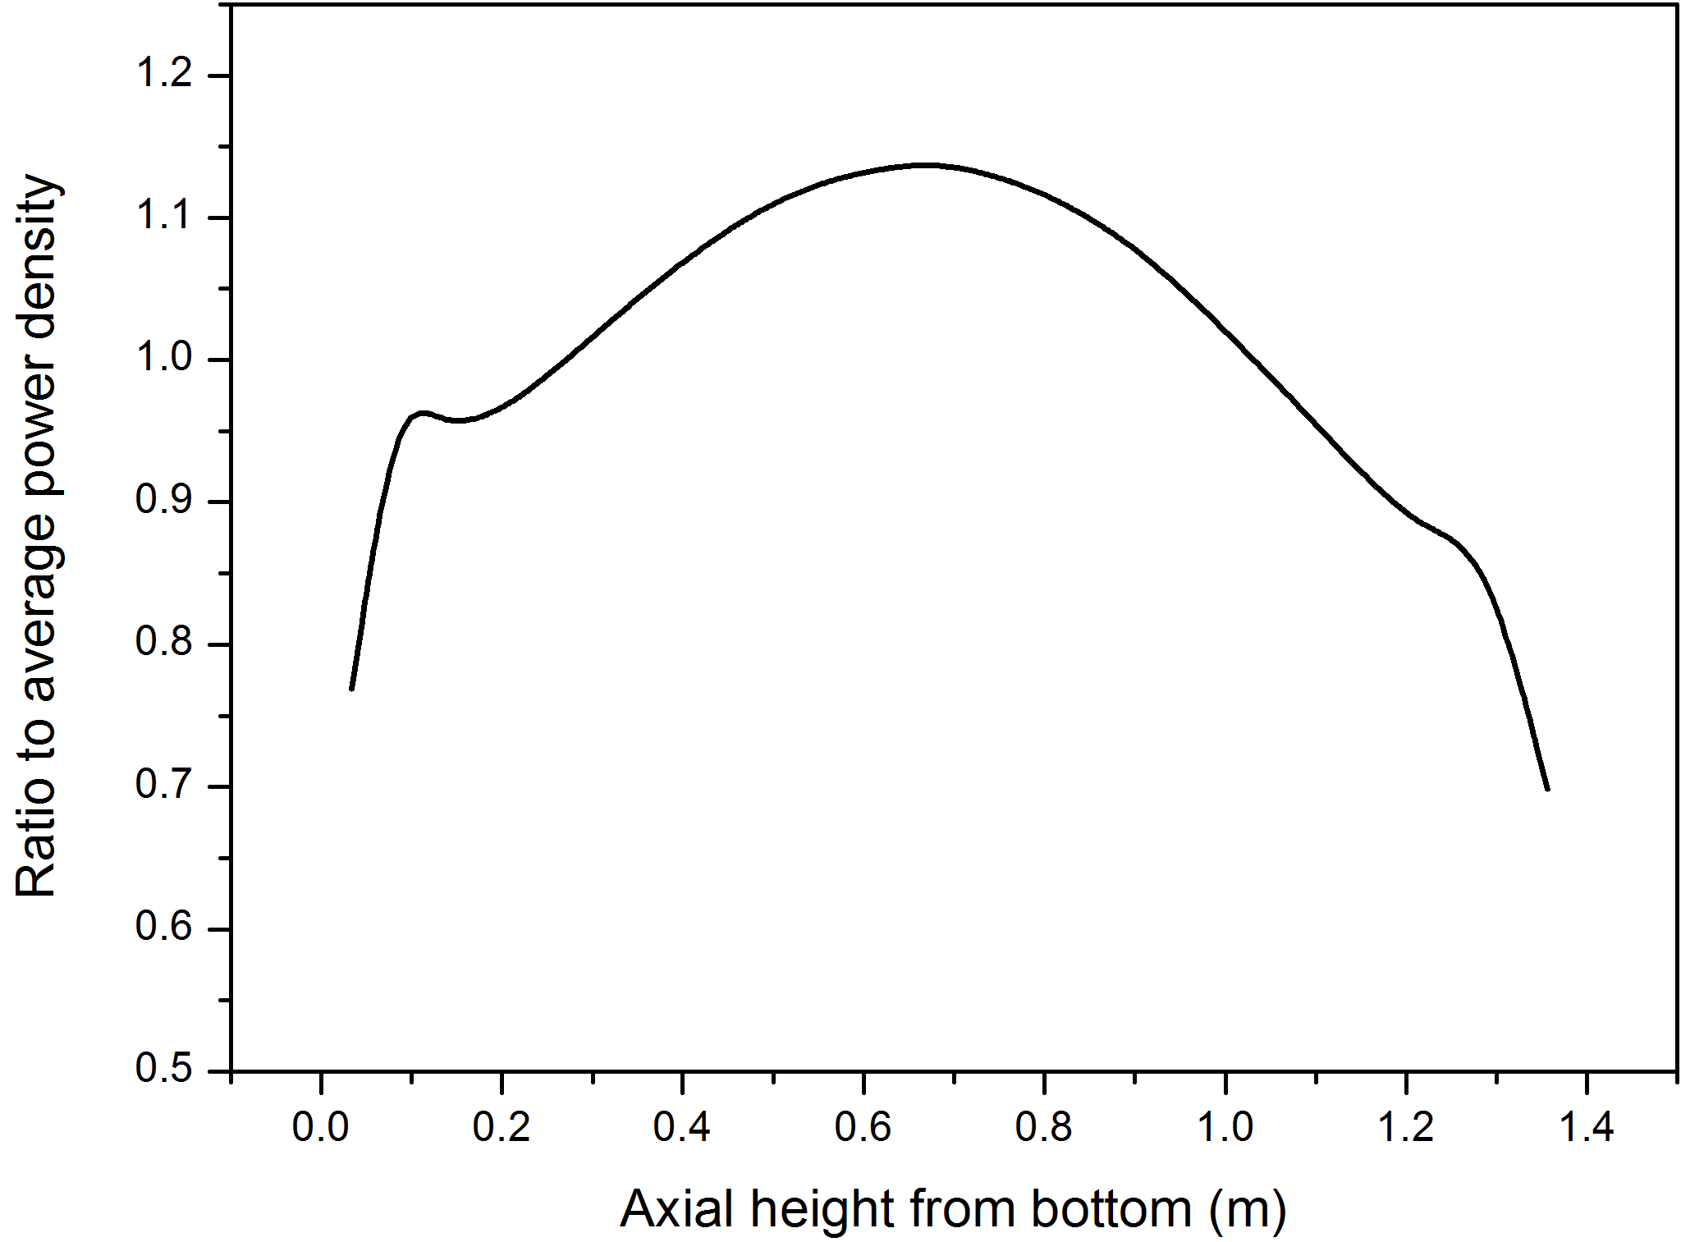
Fig. 2. Axial power distribution of SF-TMSR

V. Verification of the Limiting Safety System Settings for Forced Convection
In order to verify the derived LSSS, two fortran codes are compared for four different scenarios.
- High power mode II
- Temperature limits chosen in ICONE PAPER
  - Volumetric flow rate: 138.02m³/h
  - Maximum fuel temperature limit: 1300°C
  - Maximum coolant temperature limit: 1200°C
  - Minimum inlet temperature limit: 470°C
  - Maximum outlet temperature limit: 720°C
- Modified temperature limits (1)
  - Volumetric flow rate: 138.02m³/h
  - Maximum fuel temperature limit: 1300°C
  - Maximum coolant temperature limit: 1200°C
  - Minimum inlet temperature limit: 500°C
  - Maximum outlet temperature limit: 700°C
- Modified temperature limits (2)
  - Volumetric flow rate: 138.02m³/h
  - Maximum fuel temperature limit: 1300°C
  - Maximum coolant temperature limit: 1200°C
  - Minimum inlet temperature limit: 500°C
  - Maximum outlet temperature limit: 800°C

The results for each scenario are presented in Figures 3-5 and Table V, where subfigure/subtable a refers to CODE A and b refers to CODE B. Tabulated from Figures 3-5, Table IV, both CODE A and CODE B calculate the same LSSS to at least within tenths of a degree or MW.
TABLE IV
Tabulated LSSS Data from Figures 3-5
 | CODE A POWER (MW) | CODE B POWER (MW) | Difference (MW)
Case 1
Maximum Coolant Temperature (1200°C)
T_in = 470°C | 43.86 (T_out=704.52) | 43.87 (T_out=704.57°C) | 0.01 (0.05°C)
T_out = 720°C | 42.44 | 42.44 | 0.00
Maximum Fuel Temperature (1300°C)
T_in = 470°C | 28.05 (T_out=619.95°C) | 28.05(T_out=619.98°C) | 0.00 (0.03°C)
T_out = 720°C | 24.86 | 24.86 | 0.00
Maximum Outlet Temperature (720°C)
T_in = 470°C | 46.76 | 46.76 | 0.00
Case 3
Maximum Coolant Temperature (1200°C)
T_in = 500°C | 41.92 (T_out=725.76°C) | 41.93 (T_out=725.81°C) | 0.01 (0.05°C)
T_out = 700°C | 44.28 | 44.27 | 0.01
Maximum Fuel Temperature (1300°C)
T_in = 500°C | 27.24 (T_out=646.72) | 27.25 (T_out=646.75°C) | 0.01 (0.03°C)
T_out = 700°C | 25.53 | 25.53 | 0.00
Maximum Outlet Temperature (700°C)
T_in = 500°C | 37.14 | 37.14 | 0.00
Case 4
Maximum Coolant Temperature (1200°C)
T_in = 500°C | 41.92 (T_out=725.76°C) | 41.93(T_out=725.81°C) | 0.01 (0.05°C)
T_out = 800°C | 35.11 | 35.11 | 0.00
Maximum Fuel Temperature (1300°C)
T_in = 500°C | 27.24 (T_out=646.72°C) | 27.25 (T_out=646.75°C) | 0.01 (0.03°C)
T_out = 800°C | 21.77 | 21.77 | 0.00
Maximum Outlet Temperature (800°C)
T_in = 500°C | 55.71 | 55.71

TABLE Va
High Power Mode II – 20 MW

TEMPERATURES IN AVERAGE CHANNEL [°C]
TC | TW | TG | TCL | TCLT
601.343 | 690.518 | 747.822 | 905.995 | 936.768
606.105 | 683.619 | 735.182 | 878.520 | 905.591
610.709 | 685.190 | 735.012 | 873.844 | 899.948
615.381 | 690.502 | 740.829 | 881.014 | 907.606
620.223 | 697.614 | 749.449 | 893.607 | 921.358
625.250 | 705.103 | 758.567 | 907.001 | 936.021
630.444 | 712.412 | 767.296 | 919.454 | 949.632
635.783 | 719.486 | 775.559 | 930.842 | 962.045
641.223 | 725.940 | 782.764 | 940.034 | 971.975
646.716 | 731.696 | 788.811 | 946.883 | 979.250
652.232 | 737.022 | 794.150 | 952.301 | 984.898
657.706 | 741.276 | 797.778 | 954.357 | 986.729
663.098 | 744.910 | 800.442 | 954.550 | 986.447
668.367 | 747.824 | 801.998 | 952.617 | 983.758
673.465 | 749.875 | 802.238 | 948.168 | 978.226
678.355 | 751.234 | 801.450 | 941.789 | 970.528
683.030 | 752.336 | 800.348 | 934.912 | 962.293
687.480 | 753.114 | 798.826 | 927.330 | 953.291
691.738 | 754.245 | 797.984 | 921.263 | 946.028
695.948 | 757.453 | 800.594 | 922.300 | 946.795
699.330 | 765.663 | 811.643 | 940.927 | 967.480
W [kg/s] | T_in | T_out | TC_max | TF_max
84.6 | 600.000 | 699.330 | 765.663 | 954.550

TEMPERATURES IN HOT CHANNEL [°C]
TC | TW | TG | TCL | TCLT
601.377 | 783.102 | 857.285 | 1090.522 | 1142.244
607.638 | 768.580 | 835.709 | 1048.258 | 1093.602
617.243 | 770.981 | 835.819 | 1041.684 | 1085.405
626.755 | 780.944 | 846.233 | 1053.537 | 1098.145
636.511 | 794.473 | 861.426 | 1073.778 | 1120.434
646.633 | 808.707 | 877.453 | 1095.230 | 1144.130
657.115 | 822.552 | 892.822 | 1115.227 | 1166.181
667.917 | 835.917 | 907.421 | 1133.597 | 1186.381
678.970 | 848.074 | 920.276 | 1148.647 | 1202.767
690.181 | 858.900 | 931.248 | 1160.180 | 1215.094
701.471 | 868.937 | 941.094 | 1169.596 | 1224.970
712.741 | 876.974 | 948.182 | 1174.002 | 1229.046
723.884 | 883.896 | 953.747 | 1175.665 | 1229.945
734.817 | 889.522 | 957.559 | 1174.194 | 1227.223
745.449 | 893.594 | 959.282 | 1169.004 | 1220.214
755.691 | 896.434 | 959.379 | 1160.964 | 1209.944
765.500 | 898.854 | 958.994 | 1152.201 | 1198.881
774.858 | 900.719 | 957.946 | 1142.396 | 1186.666
783.789 | 903.277 | 957.991 | 1134.848 | 1177.095
792.473 | 909.699 | 963.564 | 1137.885 | 1179.708
800.258 | 925.280 | 982.437 | 1166.869 | 1212.298
W [kg/s] | T_in | T_out | TC_max | TF_max
67.68 | 600.000 | 800.258 | 925.280 | 1175.665

TABLE Vb
High Power Mode II - 20 MW

TEMPERATURES IN AVERAGE CHANNEL [°C]
TC | TW | TG | TCL | TCLT
600.672 | 690.518 | 747.822 | 905.995 | 936.768
603.724 | 683.619 | 735.182 | 878.520 | 905.591
608.407 | 685.190 | 735.012 | 873.844 | 899.948
613.045 | 690.502 | 740.829 | 881.014 | 907.606
617.802 | 697.614 | 749.449 | 893.607 | 921.358
622.737 | 705.103 | 758.567 | 907.001 | 936.021
627.847 | 712.412 | 767.296 | 919.454 | 949.632
633.114 | 719.487 | 775.559 | 930.842 | 962.045
638.503 | 725.940 | 782.764 | 940.034 | 971.975
643.969 | 731.696 | 788.811 | 946.883 | 979.250
649.474 | 737.022 | 794.150 | 952.301 | 984.898
654.969 | 741.276 | 797.778 | 954.357 | 986.729
660.402 | 744.910 | 800.442 | 954.550 | 986.447
665.733 | 747.824 | 801.998 | 952.617 | 983.758
670.916 | 749.875 | 802.238 | 948.168 | 978.226
675.910 | 751.234 | 801.450 | 941.789 | 970.528
680.692 | 752.336 | 800.348 | 934.912 | 962.293
685.255 | 753.114 | 798.826 | 927.330 | 953.291
689.609 | 754.245 | 797.984 | 921.263 | 946.028
693.843 | 757.453 | 800.594 | 922.300 | 946.795
697.639 | 765.663 | 811.643 | 940.927 | 967.480
W [kg/s] | T_in | T_out | TC_max | TF_max
84.6 | 600.000 | 699.330 | 765.663 | 954.550
TEMPERATURES IN HOT CHANNEL [°C]
TC | TW | TG | TCL |  | TCLT
601.377 | 783.102 | 857.285 | 1090.522 |  | 1142.244
607.638 | 768.580 | 835.709 | 1048.258 |  | 1093.602
617.243 | 770.981 | 835.819 | 1041.684 |  | 1085.405
626.755 | 780.944 | 846.233 | 1053.537 |  | 1098.145
636.511 | 794.473 | 861.426 | 1073.778 |  | 1120.434
646.633 | 808.707 | 877.453 | 1095.230 |  | 1144.129
657.115 | 822.552 | 892.822 | 1115.227 |  | 1166.181
667.917 | 835.917 | 907.421 | 1133.597 |  | 1186.381
678.970 | 848.074 | 920.276 | 1148.647 |  | 1202.766
690.181 | 858.900 | 931.248 | 1160.180 |  | 1215.094
701.471 | 868.937 | 941.094 | 1169.596 |  | 1224.970
712.741 | 876.975 | 948.182 | 1174.002 |  | 1229.046
723.884 | 883.896 | 953.747 | 1175.665 |  | 1229.945
734.817 | 889.522 | 957.559 | 1174.194 |  | 1227.223
745.449 | 893.594 | 959.282 | 1169.004 |  | 1220.214
755.691 | 896.434 | 959.379 | 1160.964 |  | 1209.944
765.500 | 898.854 | 958.994 | 1152.201 |  | 1198.881
774.858 | 900.719 | 957.946 | 1142.396 |  | 1186.666
783.789 | 903.277 | 957.991 | 1134.848 |  | 1177.095
792.473 | 909.699 | 963.564 | 1137.885 |  | 1179.708
800.258 | 925.280 | 982.437 | 1166.869 |  | 1212.298
W [kg/s] | T_in | T_out | TC_max |  | TF_max
67.68 | 600.000 | 803.725 | 925.280 |  | 1175.662

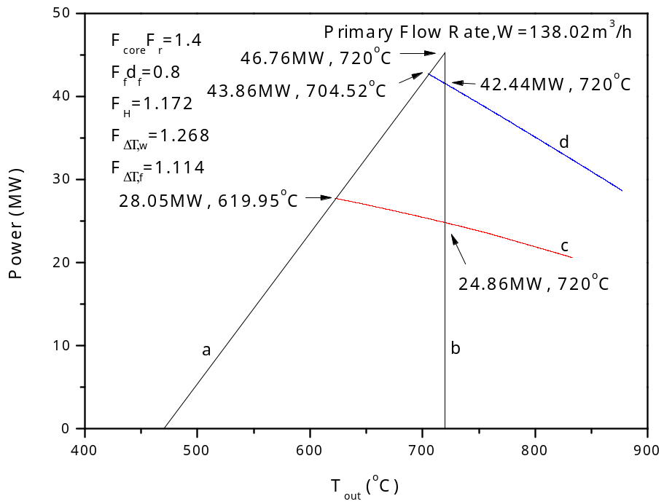
Fig. 3a. SF-TMSR limiting safety system settings for 20 MW forced-flow operation

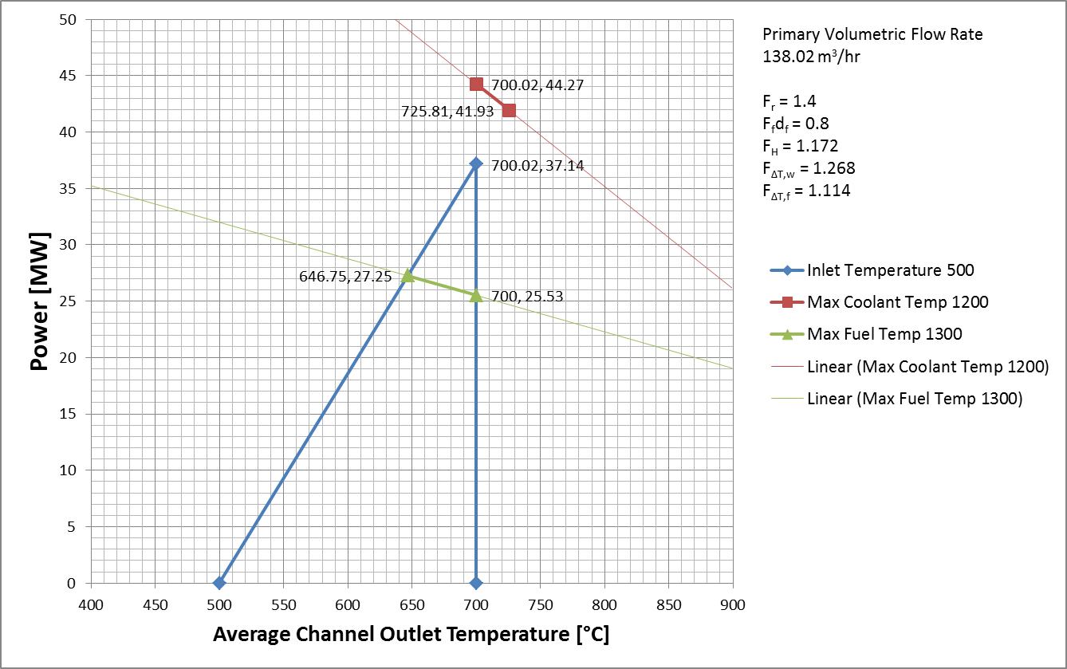
Fig. 3b. SF-TMSR limiting safety system settings for 20 MW forced-flow operation

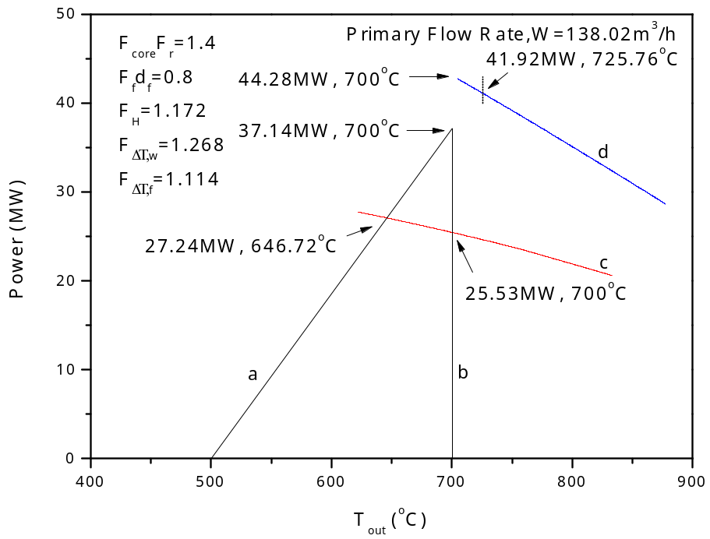
Fig. 4a. SF-TMSR limiting safety system settings for 20 MW forced-flow operation for modified temperature limits (1)

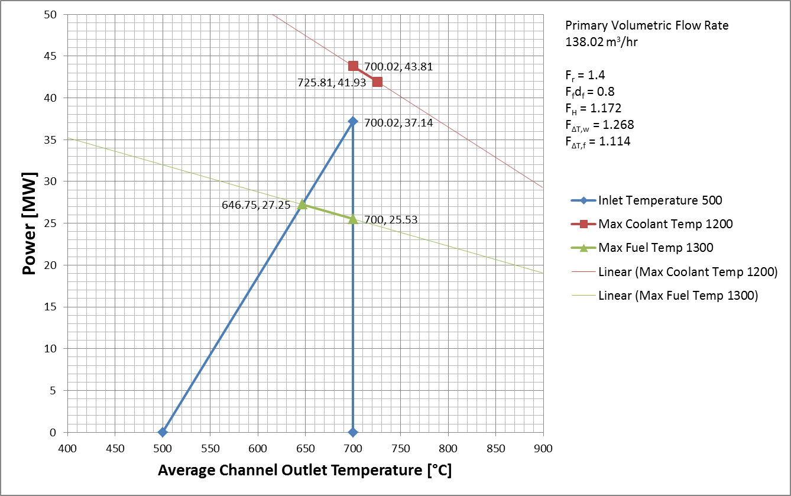
Fig. 4b. SF-TMSR limiting safety system settings for 20 MW forced-flow operationfor modified temperature limits (1)

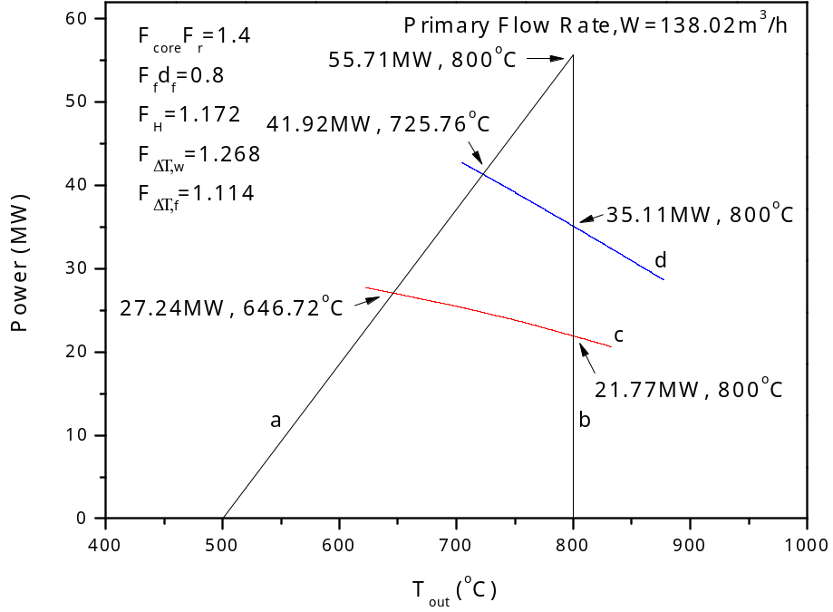
Fig. 5a. SF-TMSR limiting safety system settings for 20 MW forced-flow operation for modified temperature limits (2)

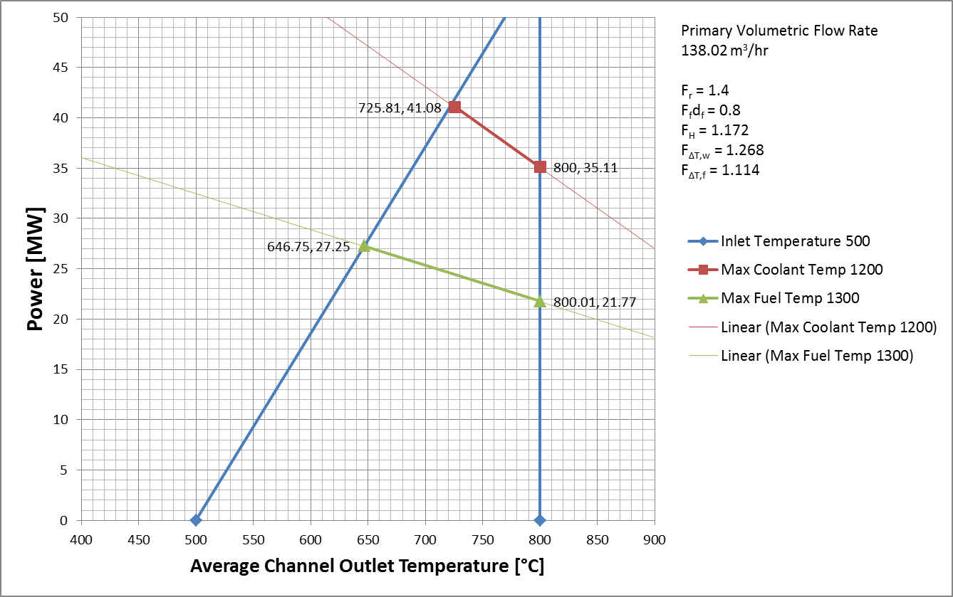
Fig. 5b. SF-TMSR limiting safety system settings for 20 MW forced-flow operation for modified temperature limits (2)

VI. CONCLUSION
The limiting safety system settings of the SF-TMSR were derived based on the constraints of flibe freezing temperature, boiling temperature, maximum fuel temperature limit, and structure component Hastelloy N maximum operating temperature limit. Based on these constraints, the same LSSS were calculated by each code.

REFERENCES
[1] Ingersoll, D. T., Forsberg, C. W., Ott, L. J., Williams, D. F., and al., e., 2004, "Status of Preconceptual Design of the Advanced High-Temperature Reactor (AHTR)," ORNL/TM-2004/104, Oak Ridge National Laboratory.
[2] Ingersoll, D. T., and Forsberg, C. W., "Overview and status of the advanced high-temperature reactor," Proc. American Nuclear Society Embedded Topical Meeting - 2006 International Congress on Advances in Nuclear Power Plants, ICAPP'06, June 4, 2006 - June 8, 2006, American Nuclear Society, pp. 598-606.
[3] Peterson, P. F., and Zhao, H., "A flexible baseline design for the Advanced High Temperature Reactor using Metallic Internals (AHTR-MI)," Proc. American Nuclear Society Embedded Topical Meeting - 2006 International Congress on Advances in Nuclear Power Plants, ICAPP'06, June 4, 2006 - June 8, 2006, American Nuclear Society, pp. 650-661.
[4] Bickel, J. E., Laufer, M. R., Li, L., Cisneros, A. T., and Peterson, P. F., "Conceptual design, experiments, and analysis for the core of an FHR-16 test reactor," Proc. International Congress on Advances in Nuclear Power Plants 2010, ICAPP 2010, June 13, 2010 - June 17, 2010, American Nuclear Society, pp. 1281-1291.
[5] Forsberg, C. W., Hu, L. W., Peterson, P. F., and Sridharan, K., 2012, "Fluoride-Salt-Cooled High-Temperature Reactors (FHRs) for Base-Load and Peak Electricity, Grid Stabilization, and Process Heat," MIT-ANP-TR-147, Department of Nuclear Science and Engineering, Massachusetts Institute of Technology, Cambridge, MA.
[6] SINAP, 2012, "Pre-conceptual Design of a 2MW Pebble-bed Fluoride Salt Coolant High Temperature Test Reactor," Shanghai Institute of Applied Physics.
[7] Jiang, M. H., Xu, H. J., and Dai, Z. M., 2012, "Advanced Fission Energy Program-TMSR Nuclear Energy System," Bulletin of Chinese Academy of Sciences, 27(3), pp. 366-374.
[8] NRC, 1996, "Guidelines for Preparing and Reviewing Applications for the Licensing of Non-Power Reactors," No. NUREG-1537, Office of Nuclear Reactor Regulation, Nuclear Regulation Commission.
[9] ANS, 2007, "The Development of Technical Specifications for Research Reactors," No. ANSI/ANS-15.1-2007, American Nuclear Society.
[10] SINAP, 2012, "TMSR Internal Technical Report XDA02010200-TL-2012-09," (in Chinese), Shanghai Institute of Applied Physics.
[11] Collier, J. G., and Thome, J. R., 1994, Convective boiling and condensation, Oxford University Press.
[12] Yujun, G., Jinling, Z., Suizheng, Q., Guanghui, S., Dounan, J., and Zhenwan, Y., "MITARS-a thermal hydraulic analysis code for nuclear reactor system," Proc. Proceedings of 8th International Topical Meeting on Nuclear Reactor Thermal Hydraulics, 30 Sept.-4 Oct. 1997, Atomic Energy Soc. Japan, pp. 1212-1219.
[13] Su, G. H., Jia, D. N., Fukuda, K., and Guo, Y. J., 2001, "Theoretical study on density wave oscillation of two-phase natural circulation under low quality conditions," J. Nucl. Sci. Technol., 38(8), pp. 607-613.
[14] Zuying, G., and Lei, S., 2002, "Thermal hydraulic calculation of the HTR-10 for the initial and equilibrium core," Nuclear Engineering and Design, 218(1-3), pp. 51-64.
[15] Wakao N, and S., K., 1982, Heat and Mass Transfer in Packed Beds[M]. New York: Gordon and Breach.
[16] Forsberg, C. W., Peterson, P. F., and Williams, D. F., "Liquid-salt cooling for Advanced High-Temperature Reactors," Proc. American Nuclear Society - International Congress on Advances in Nuclear Power Plants 2005, ICAPP'05, May 15, 2005 - May 19, 2005, American Nuclear Society, pp. 2080-2095.
[17] Ergun, S., 1952, "Fluid flow through packed columns," Chemical Engineering Progress, 48(2), pp. 89-94.
[18] Macdonald, I. F., El-Sayed, M. S., Mow, K., and Dullien, F. A. L., 1979, "Flow through porous media-the Ergun equation revisited," Industrial and Engineering Chemistry, Fundamentals, 18(3), pp. 199-208.
[19] Churchill, S. W., 1977, "FRICTION-FACTOR EQUATION SPANS ALL FLUID-FLOW REGIMES," Chemical Engineering (New York), 84(24), pp. 91-92.
[20] Kim, S. J., Hu, L. W., and Dunn, F., "Thermal-Hydraulic Analysis for High Enrichment Uranium (HEU) and Low Enrichment Uranium (LEU) Transitional Core Conversion of the MIT Research Reactor," Nuclear Technology (in press).
[21] MITR-Staff, 2011, "Safety Analysis Report for the MIT Research Reactor," MIT Nulcear reactor Laboratory.
[22] Chunhe, T., Yaping, T., Junguo, Z., Yanwen, Z., Jihong, L., and Xiaojun, N., 2002, "Design and manufacture of the fuel element for the 10 MW High Temperature Gas-cooled Reactor," Nuclear Engineering and Design, 218(1-3), pp. 91-102.
[23] Hu, L. W., and Bernard, J. A., 1998, "Thermal-hydraulic analysis for the upgraded MIT nuclear research reactor," IEEE Transactions on Nuclear Science, 45(3), pp. 1040-1044.
[24] Todreas, N. E., and Kazimi, M. S., 1990, Nuclear Systems I - Thermal Hydraulic Fundamentals, Hemisphere Publishing.
[25] NRC, 2004, "TRISO-Coated Particle Fuel Phenomenon Identification and Ranking Tables (PIRTs) for Fission Product Transport Due to Manufacturing, Operations, and Accidents," No. NUREG/CR-6844, Vol. 1, Office of Nuclear Reactor Regulation, Nuclear Regulation Commission.
[26] Zou, Y., 2012, "Personal Communication with Dr. Yang Zou," (in Chinese), Shanghai Institute of Applied Physics.

[27] Xiao, Y., Hu, L. W., Forsberg, C., Qiu, Suizheng, and Su, Guanghui, 2013, "Licensing Considerations of a Fluoride Salt Cooled High Temperature Test Reactor," Proceedings of the 2013 21st International Conference on Nuclear Engineering, ICONE21, July 29 - August 2, 2013, ICONE21-16383, Chengdu, China.

